BGU Community Music Newsletter, Spring 2018

Rehearsal Dates

Just a reminder of dates and times, etc. for all BGU Community Music Activities!

- Mondays, 7pm-8.15pm. The Victoria Function Room, Union Road, Lincoln. SCONE: Steampunk Choir of Notorious Excellence. Subs by donation.
- Tuesdays, 2pm-4pm. The Venue Clubroom, Navenby. Treble Cliff Choir. Subs £5.
- Wednesdays, 6pm-7.30pm. Teaching Room 2, Hardy Building, Bishop Grosseteste University. BGUkes Ukulele group. Subs £2.50.
- Thursdays, 6pm – 7.15pm. The Chapel, Bishop Grosseteste University. Vocal Authority & Coop Choir. Subs £5.

We always welcome new members, no requirement to read sheet music is necessary, although you do tend to pick it up as you go along!

I am currently making enquiries about potentially moving the Ukulele Group south of the city, as the trip into the city is difficult for many people. More details as they become available!

Spring Concert Date
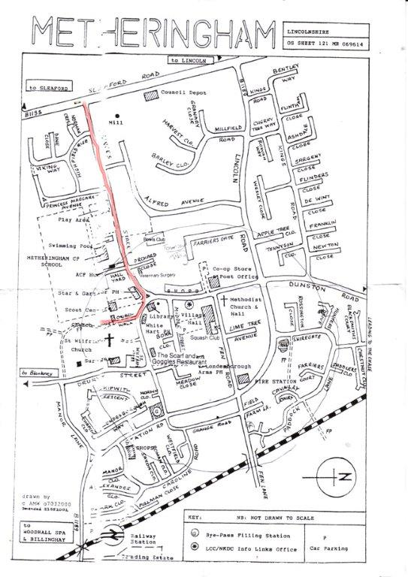
Vocal Authority, Coop Choir and Treble Cliff have been invited to sing on Sunday 18th March at Metheringham Village Hall between 3-4pm. There will be another choir performing half the programme, and we will be doing half an hour, including the new material that we have been looking at (I’m still in two minds about “Caledonia”, though!). Jayne (my contact with the other choir) has said this about parking:

“There is public parking in the Village Hall car park, access off Middle Street, not Fen Road, or on a Sunday in the Church Walk GP surgery on Drury Street, they are my next door neighbours- no surgery on a Sunday afternoon”

She also sent a helpful map, demonstrating this which you will find to the left. I will put this on the website in the “Newsletter” section in greater detail.

Website Details

As new people join all the choirs and groups, they may not be aware that all teaching is supported by our website:

http://www.community-choirs.co.uk/

Which features a blog with articles about singing and creativity, and links to videos of our various groups singing, and most helpfully perhaps, all the soundtrack and music downloads.

For the sheet music/words page, there is a password so that we comply with copyright law – I buy the permissions for sheet music to be used by my choirs, not by anyone else. The password that you need to enter is: bgusings

Summer Concert Date

I am looking at scheduling a date for our Annual Concert – I am thinking July 21st… Does that clash with anyone? It will be in the Chapel at Bishop Grosseteste University with a reception afterwards in The Snug, hopefully with a bit of ukulele madness from the BGUkes people!

Annie has Booked a Holiday Shock!!!

I try not to book holidays during choir times, but have realised that actually, you’d probably all forgive me if I took a week off occasionally, right? With this in mind, I have booked a holiday the week of 25thJune to 1st July, 2018. I’m going to Hay-on-Wye for an actual, honest to goodness holiday. I’m slightly in shock. I never get real holidays!

SCONE at The Asylum

The Steampunk Choir of Notorious Excellence will be applying to perform at Asylum again in 2019. Due to the hectic nature of programming, I don’t expect we will get confirmation of dates and venues until the early part of August, but given how much fun it was last year, I would love to do it again!

We are also hoping to go into the studio with The Captain of the Lost Waves at some point between now and then.

Right, I think that’s about it for now! Love you all!

Annie

Tel: 07415 212183 / 01400 273698
Email: annie@anniegriffith.co.uk

